Choi Tim Anthony Young

Dimitri Garcia

Laurice Sattouf

ECE4304- Lab 1

2/8/2021

Professor M. Aly

**Implementing Generic Mux 64x1 using Mux2x1**

**Purpose:**

* The purpose of this lab is to implement the generic mux64x1 using mux2x1 in VHDL.
* The mux 2x1 is the base component that we used to generate the rest of the Muxes using the generic and for generate instructions in the RTL design.
* The Muxes will be places into layers of Muxes:
  + N is the number of inputs.
  + Log2(N) = # of layers = # of selects

In our example: N = 64 and the layers = 6.

* This circuit is fully combinational.

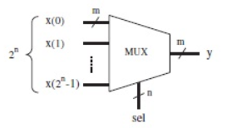**Circuit Design:**

**Coding steps:**

1. Create the base component Mux2x1.
2. Create the desired entity Mux Nx1.
3. Use “for generate” to generate the layers of Muxes.
4. Use the testbench to verify the results.

For this lab, we are asked to use the textio Library in order to import inputs to the test bench and save the outputs into a separate txt file.

**Schematic from Vivado:**

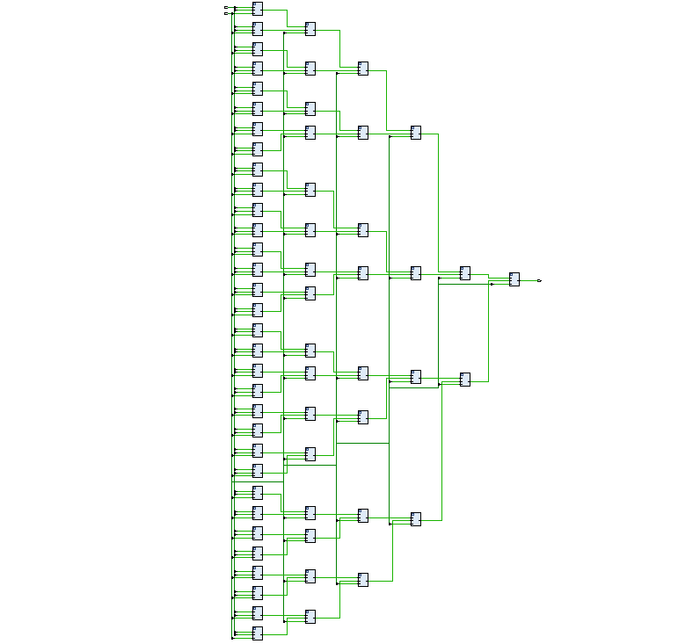

Schematic of mux64x1 using Vivado.

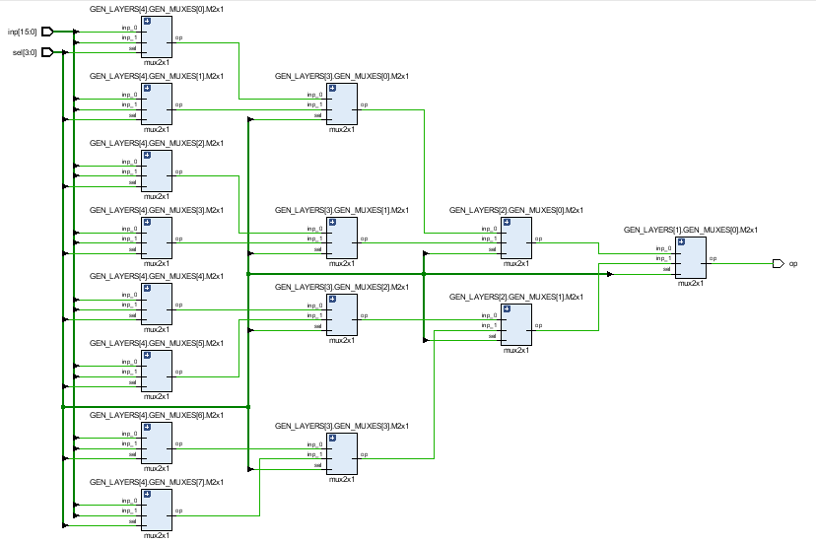Schematic of mux16x1 using Vivado.

**Power and resources used:**



17 look up tables was used with total energy of 2.862:

The reason of having high amount of power usage is that the circuit is completely combinational and that bring more power consumption.

**Test bench screenshot:**

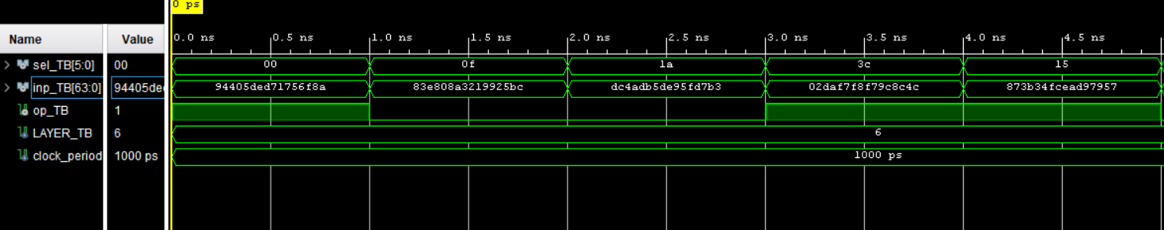Some values that we tested in VIVADO.

**Difficulties:**

The main problem with this lab is getting familiar with VHDL syntax and applying all the knowledge we earned in order to proceed and implement the design.

In order to cover all the corner cases, we create a test bench script to generate random inputs, and we used that to test as much data as possible.

**Work Contribution:**

* We all worked individually on the code and then we had a discussion session to combine all the work.
* We had a zoom meeting to demo and cover all the corner cases.
* Documentation and reports were evenly distributed, and it covered all the steps of our successfully implemented design.